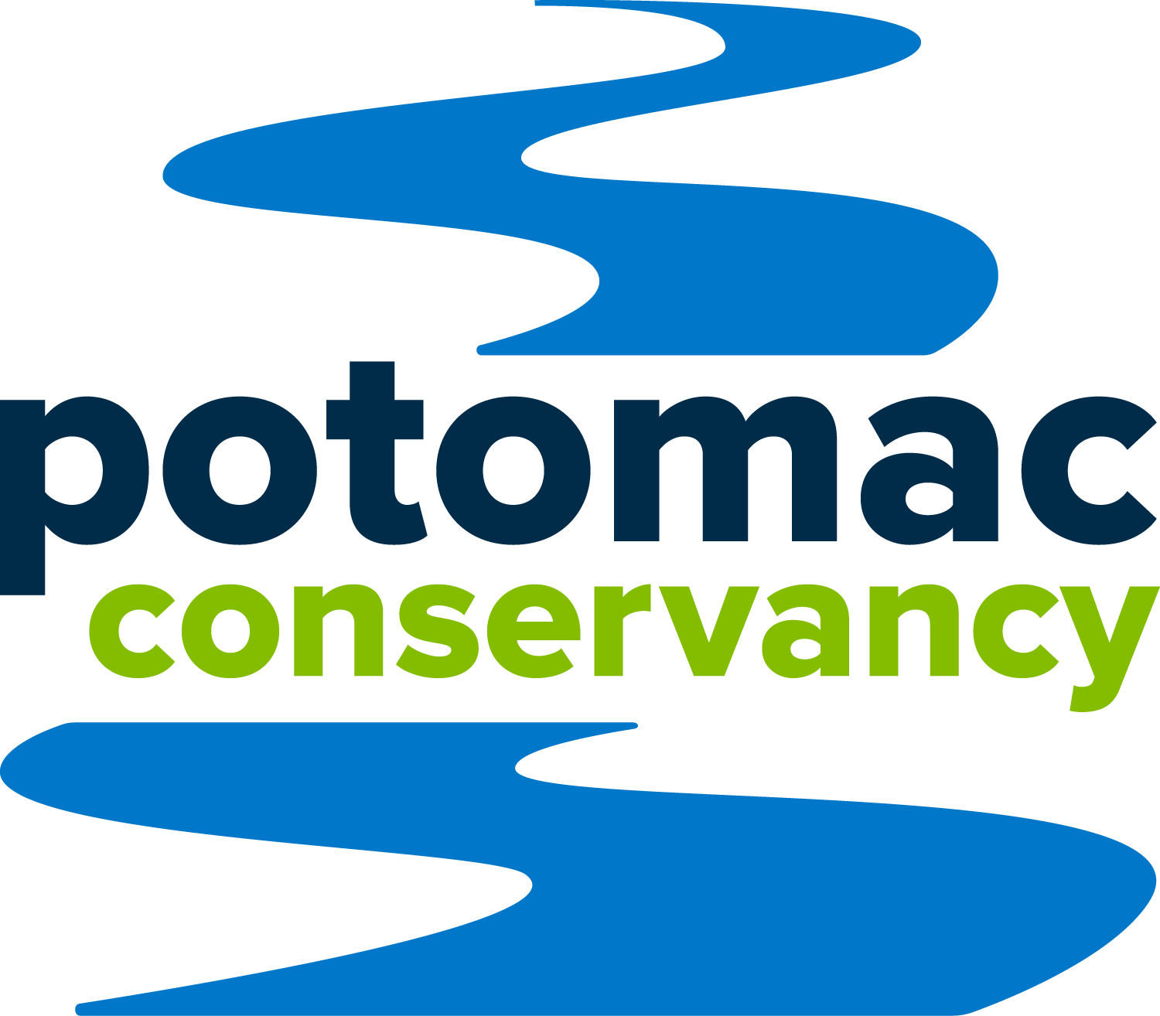

New report finds the Potomac River’s health is improving,
but it’s not yet safe for swimming and fishing
www.potomacreportcard.org
May 16, 2023 SILVER SPRING, MARYLAND | Potomac Conservancy has scored the Potomac River’s health a “B” grade in its 2023 Potomac River Report Card.
The current health of the river, the source of drinking water for 5 million people, is an improvement from a “B-” three years ago and a dreadful “D” in 2011.
The Conservancy’s Report Card assesses over 20 ecosystem indicator measures for pollution, fish, habitat, land, and recreation. Top pollutants (nitrogen, phosphorus, and sediment) are on track to meet 2025 federal reduction goals, making the Potomac River a success story of the broader Chesapeake Bay restoration initiative.
The Potomac’s comeback is a testament to decades of hard work to reduce pollution and restore local water quality.
“The Potomac River is one of the Chesapeake Bay region’s most precious natural resources,” said Potomac Conservancy President Hedrick Belin, adding, “As the source of the water we drink, an economic driver of local fisheries, and home to natural wonders, the Potomac is critically important to our communities and public health. We must do everything we can to continue to reduce pollution and restore the health of our forests and streams.”
POSITIVE TRENDS
- Industrial and farming pollution are declining
  - All top pollutants (nitrogen, phosphorus, and sediment) are on track to meet 2025 federal pollution reduction goals.
- Bald eagles, shad, and local wildlife are rebounding
  - The Potomac River is one of the only Chesapeake Bay tributaries where shad have successfully recovered.
- More shoreline visitors, anglers, and water recreationists are enjoying the Potomac
  - Sports fishing licenses quadrupled during the pandemic.
There’s been significant progress to clean up our “Nation’s River,” but pollution remains a problem. Polluted urban runoff is the only growing source of pollution to the Potomac River and threatens restoration efforts. Combatting polluted runoff is becoming more difficult as the changing climate impacts the local ecosystem.

TOP THREATS
- Polluted urban runoff is the only growing source of pollution to the Potomac River and it threatens decades of restoration progress
  - Runoff pollutes local waterways with fertilizers, street oils, trash, sediment, and diluted sewage.
- Rapid deforestation in the region is weakening nature’s defenses against polluted runoff.
  - Among the 20+ ecosystem indicators, streamside forests received one of the worst grades scoring a D+. This signals the region is not meeting its forest protection goals.
- The climate crisis is straining the local ecosystem from intensifying storms lengthening droughts, rising river levels, and warming stream temperatures.
  - Flash flooding and threats to indigenous trees and vegetation are making it harder to combat polluted runoff.
The report calls on decision-makers and the community to invest in land-use solutions that reduce polluted runoff and make the ecosystem more resilient to climate change.
“As with all rivers, the Potomac River is only as healthy as the lands that surround it. We can’t bulldoze our way out of our water and climate crises,” said Belin adding, “We must leave behind a 20th-century mindset where we pave over forests and deal with the consequences later. It’s time for leaders to embrace bold, nature-based solutions for the protection of our rivers, drinking water sources, and public health.”
###
About the Potomac River:
- The drinking water source for five million residents in the greater Washington, DC metro area.
- The second largest tributary to the Chesapeake Bay. Its waters flow over 400 miles and its watershed spans four states (MD, PA, VA, WV) and the District of Columbia.
- Home to over 1,400 native plants and animals, and 200 globally rare species.
- Flows over 380 miles through West Virginia, Pennsylvania, Virginia, Maryland, and Washington, DC.
- Supports a local population of bottlenose dolphins; one of the only witnessed wild dolphin births in the world occurred in the Potomac River in 2019.

About the Report
The Potomac River Report Card presents and assesses data on five significant river health indicators: pollution, fish, habitat, land, and people. Data sets for some indicators take time to become publicly available, so we have aggregated and assessed data through 2020. Using an established baseline and set of benchmarks, the Conservancy measures restoration progress and assigns the Potomac River a grade. The overall grade has been weighted to account for non-quantifiable, inaccessible, or outdated data on water quality threats. These threats include, but are not limited to, harmful algal blooms, warming waters, endocrine-disrupting compounds, PCBs, aquatic diseases, and others.

About Potomac Conservancy
Potomac Conservancy is a nationally accredited land trust and clean water leader in the Potomac River region. We’re committed to restoring the Potomac to full health for the five million people who rely on the river for drinking water and outdoor enjoyment. We improve local water quality through land conservation initiatives that effectively stop pollution from entering our streams and tributaries. Our impassioned base of 30,000 supporters empowers us to protect and expand streamside forests, pass water protection laws, and restore local shorelines. Learn more at www.potomac.org.
FOR MORE INFORMATION visit potomacreportcard.org or contact Melissa Diemand at diemand@potomac.org or 413-478-0568.

